**List of Exercise:**

1. Write a menu driven C Program using Singly Linked List to store the Student Data and perform the following operations:
   1. Create a singly linked list to store the student data with the fields: Rollno, Name, Branch and PhoneNo.
   2. Delete student information from the above linked list and display the content after deletion.
   3. Traverse the list and search for a particular student information
2. Implement a menu driven C program for the following operations on Doubly Linked List (DLL) of Employee Data with the fields: SSN, Name, Dept, Designation, Sal, PhNo
3. Create a DLL of N Employees Data by using end insertion.
4. Display the status of DLL and count the number of nodes in it
5. Perform Insertion and Deletion at End of DLL
6. Perform Insertion and Deletion at Front of DLL
7. Implement a menu driven C program for the following operations on STACK of Integers using the concept of Array

(1) Push an Element on to the Stack

(2) Pop an Element from Stack

(3) Demonstrate Overflow and Underflow situations on Stack

(4) Display the data available on a stack

1. Implement a menu driven C program to perform various operations on linear QUEUE using the concept of Array.
2. An application requires a data structure that can store a potentially very large number of records, with the data being added as it arrives. This data structure should able to retrieve a record by its primary key, and these keys are random with respect to the order in which the data arrives. Records also may be deleted at random times, and all modifications to the data need to be completed just after they are submitted by the users. There is no idea how large the dataset could be, but the data structure implementation needs to be ready in a few weeks. Design a suitable hash table that reflects the above mentioned properties.
3. Bank must support many types of transactions with its customers. Develop a simple   
   model where customers wish to open accounts, close accounts, and add money or   
   withdraw money from accounts using hash tables.
4. In the graph below each vertex represents an island and each edge would be the cost   
   (in millions of dollars) to build a bridge to connect those two islands via a road. You must find a way to build bridges so that one can drive between any two islands with the goal of minimizing the construction cost using Prim’s algorithm.

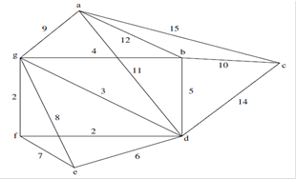

1. Jonathan has a hobby of traveling around the number of places during vacation. The following graph shows the distance from his place **a** to all other places. Help Jonathan to   
   travel from his place to any other place with the shortest path. Use Dijkstra’s technique to   
   find the shortest path.

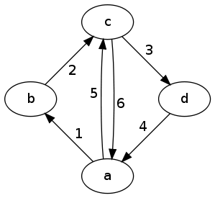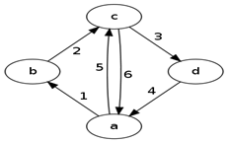

1. Write a C program to implement a lottery draw which uses Open addressing hash

table -linear probing for the follwing lottery numbers 4371, 1323, 6173, 4199, 4344,   
 9679, 1989 and a hash function h(X) =X (mod10).

1. Raju wants to travel from one place to all other places. But he wants to visit all the places in breadth first search order. Help Raju to find a shortest path for the following graph.

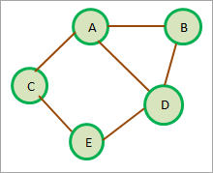

1. Harvey Jacobson wants to deploy a cargo network in six cities .He wants to move his   
   cargo goods across the cities in minimum spanning distance. Write a C program to   
   implement this scenario in Prim’s algorithm for the following graph.

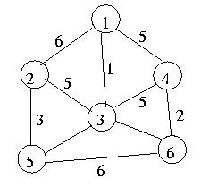

1. A cable company wants to connect five villages to their network which currently extends to the market town of A. Find the minimum length of cable needed to connect all the villages using depth first search.

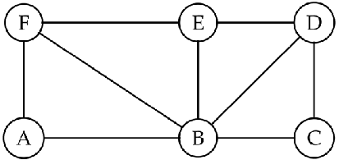

1. Flipkart, a famous e-commerce company wanted to deploy a delivery person to deliver   
   products across six inter connected location. Write a C program to help the newly appointed delivery person to deliver products in minimum span by using Kruskal’s algorithm for the following graph.

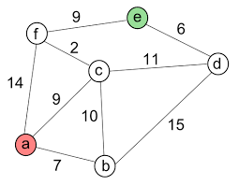

1. ABC Company wants to know the travelling distance of their employees from their residence to facilitate them with cab service. Write a C program to perform the percolate up and percolate down operations in a binary heap and show the result of Inserting the travelling distance of various employees 10,12,1,14,6,5,8,15,3,9,7,4,11,13 and 2, one at a time into an initially empty Binary Heap.
2. Rahul wants to check whether a set of values are divisible by 7.Write a C program to implement Hashing and separate chaining as the Collision resolution technique by storing the values 25, 42, 96, 101, 102, 162, 197 into the hash table using division method with a table size of 7.
3. William Carter wants to invite his friends for his wedding. He needs to travel in minimum time and invite his friends across the state. Write a C program to implement a minimum path using Kruskal’s algorithm for the following graph.

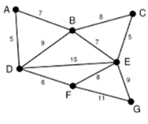

1. In a library, each book is assigned a unique number that can be used to determine information about the book, such as its exact position in the library can be found to issue book. The book's unique number keyed using natural number ranges from 0 to 9.

Write a C program to insert the following unique numbers 1234, 5678, 8765,1023,1456,7645,8932,2319 and 2387 into a hash table.

1. ABC Company wants to transfer manual employee's record to database. Manual employee record contains phone number and salary details. Store employee salary keyed using phone numbers. Phone numbers ranges from (101-109) and salary as follows 1200,100,500,5678,9876,4321,6543,8967,3456,6345,9834. Key function for mapping is H(x)=x mod table size.
2. 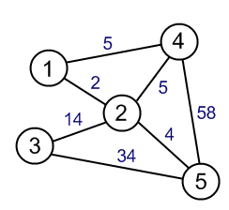A government agency identified that dengue, a mosquito born disease has spread in five major connected cities. The medicines to cure this disease has been produced in city Write a C program to help the government to transit these medicines across the five cities using Dijkstra’s algorithm.
3. Find a way to build bridges so that one can drive between any two islands using depth first search algorithm. In the graph below each vertex represents an island and each edge would be the cost (in millions of dollars) to build a bridge to connect those two islands via a road.

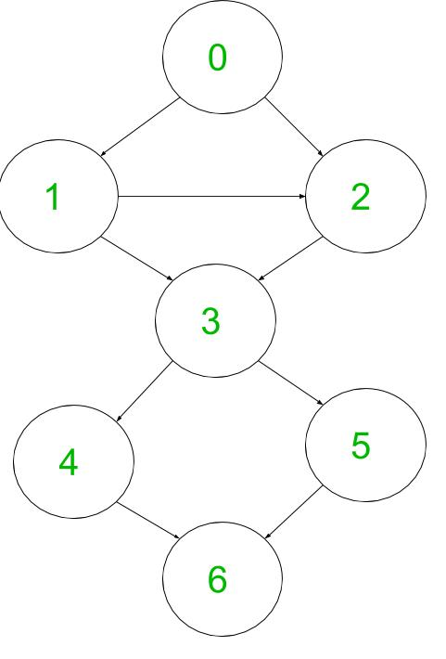

1. Implement a binary tree using C, given a root and a number K. You have to find all nodes at distance K from given root node.

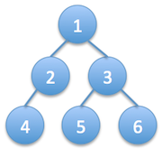For example in the given binary tree,

* If K =2 then output should be 4,5,6
* If k = 1 then output should be 2,3

1. Write a C program to implement a Binary Search Tree. Write a function to calculate the difference between the sum of node values at odd levels and sum of node values at even levels.

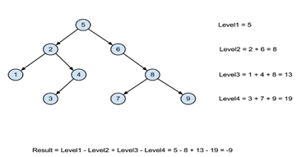

1. Suppose the numbers 7, 5, 1, 8, 3, 6, 0, 9, 4, 2 are inserted in that order into an initially empty binary search tree. The binary search tree uses the usual ordering on natural numbers. Write a C program to find the in-order traversal sequence of the resultant tree.
2. Saranya has a hobby of traveling around the number of places. The following graph shows the distance between one place to another place. Help Saranya to travel from any place to place with the shortest path. Write a C program to find the shortest path using Floyd’s algorithm.

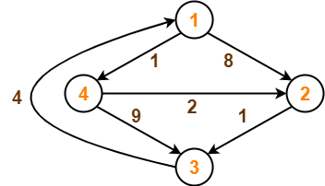

1. The keys 12, 18, 13, 2, 3, 23, 5 and 15 are inserted into an initially empty hash table of length 10 using open addressing with hash function h(k) = k mod 10 and linear probing. Write a C program to result the hash table after inserting all the values.
2. Construct the Tournament tree, which is a form of max heap which is a complete binary tree. In a tournament tree every internal node contains winner and every leaf node contains one player. Each player is represented with the score of the player. Select the best player among N players, (N – 1) players to be eliminated, i.e. we need minimum of (N – 1) games (comparisons).
3. Given n cities and distances between every pair of cities, select k cities to place warehouses (or ATMs or Cloud Server) such that the maximum distance of a city to a warehouse (or ATM or Cloud Server) is minimized.

For example consider the following four cities, 0, 1, 2 and 3 and distances between them, how do place 2 ATMs among these 4 cities so that the maximum distance of a city to an ATM is minimized.

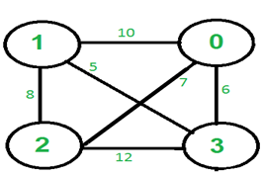

k=2

The two ATM’s should be placed in cities 2 and 3. The maximum distance of a city from an ATM becomes 6 in this optimal placement.

Apply Dijkstra’s algorithm to provide shortest path from any city to all other cities.

1. Given n ropes of different lengths. These ropes are connected into one rope. The cost to connect two ropes is equal to sum of their lengths. Connect the ropes with minimum cost. Use the appropriate data structure to store the length of rope and access the minimum cost using delete minimum operation.

For example if we are given 4 ropes of lengths 4, 3, 2 and 6. We can connect the ropes in following ways.  
1) First connect ropes of lengths 2 and 3. Now we have three ropes of lengths 4, 6 and 5.  
2) Now connect ropes of lengths 4 and 5. Now we have two ropes of lengths 6 and 9.  
3) Finally connect the two ropes and all ropes have connected.

Total cost for connecting all ropes is 5 + 9 + 15 = 29. This is the optimized cost for connecting ropes. Other ways of connecting ropes would always have same or more cost. For example, if we connect 4 and 6 first (we get three strings of 3, 2 and 10), then connect 10 and 3 (we get two strings of 13 and 2). Finally we connect 13 and 2. Total cost in this way is 10 + 13 + 15 = 38.

1. Ramu has a hobby of traveling around the number of places. The following graph shows the distance between one place to another place. Help Raju to travel from any place to place with the shortest path. Write a C program to find the shortest path using Floyd’s algorithm.



1. Write a C program to implement a queue which displays the various process id that are waiting for printing jobs. Also, has options to add/remove process to/from the queue. The initial lists of processes are given below.

4371, 1323,6173,4199,4344, 9679, 1989

1. Implement a menu driven C program for the following operations on STACK of Integers using the concept of Array
   1. Push (5)
   2. Push(10)
   3. Pop( )
   4. Push(15)
   5. Push(17)
   6. Top
   7. Demonstrate Overflow and Underflow situations on Stack
   8. Display the data available on a stack